sudo apt-add-repository ppa:ansible/ansible
sudo apt update
sudo apt install ansible -y

SSH Connection between Ansible Control node to target servers:
Private key file Method:
Use the private key of existing target servers.
Step1: download the private key of target servers
Step 2: chmod 400 privatekeyname
Step3: give the target server ip and location of private key in inventory file like below
Step 4: test connection using command,
ansible all -i inventoryfilelocation -m ping
Pls refer to recording for any queries on ssh connection

basic inventory file
If the you are using private key to connect to target servers
[all]
172.31.33.232 ansible_ssh_private_key_file="location of privatekey"

Execution of playbook
Check host file

Ansible-playbook playbookname.yml --syntax-check
ansible-playbook playbookname.yml --check

ansible all --list-hosts
58 nano host.ini
59 ansible all --list-hosts
60 pwd
61 ansible all -i /home/ubuntu/host.ini --list-hosts
62 ansible all -i /home/ubuntu/host.ini -m ping
63 history

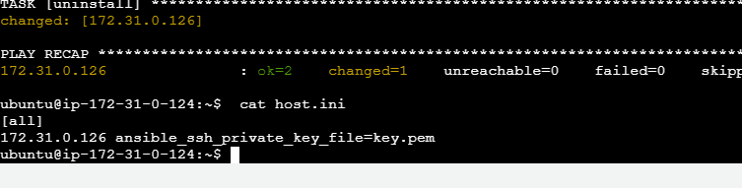



ansible-playbook -i host ansible_tags.yml --list-tags
ansible-playbook -i host ansbletags.yml --tags first

how to execute multiple tags
ansible-playbook -i host ansible_tags.yml –-tags first,second

